Viscosity project summary_Section 2_ML

Table of content

**Standard 398.5 cP 2**

Set: Full 2

Set: Full (unorderedT) 9

Set: 1 14

Set: 1 (unorderedT) 21

**Standard 1275 cP 25**

Set: Full 26

Set: 1 31

# Standard 398.5 cP

Machine learning segment

## Set: Full

Observation of trends

Observation 1: GPR - scaling: Division and LIN - scaling: Multiplication and Division

Once an ‘optimal’ set of parameters are attained, it will double check one time to confirm, then continue to explore parameters. The ‘confirmation’ stage usually occurs in trial 5 or 6 of the 10 trials and it can continue to suggest parameters that deviate quite far from the ‘optimal’ set of parameters.

Observation 2: GPR - scaling: Multiplication

Once an ‘optimal‘ set of parameters are attained, it will remain the same for the rest of the 10 trials. The ‘optimal’ set of data is usually attained in trial 5 or 6 too, similar to when division is used for scaling.

Observation 3: GPR - scaling: Without and LIN - scaling: Without

A converging trend is observed for percentage error. The first 2 trials’ %error usually falls between 5-6% but it converges towards 0 from trial 2-9. However, trial 10 deviated from the consistency observed between trial 2-9. Unlike the trials with GPR-multiplication used in the scaling code (stays the same after ‘optimal’ parameters are found), the parameters continue to change slightly after the ‘optimal’ set of parameters are attained. For that, GPR without scaling can be said to be somewhere between when division and multiplication are used for the scaling parameters (continues to ‘explore’ moderately after ‘optimal set’ is found).

LIN scaling: division

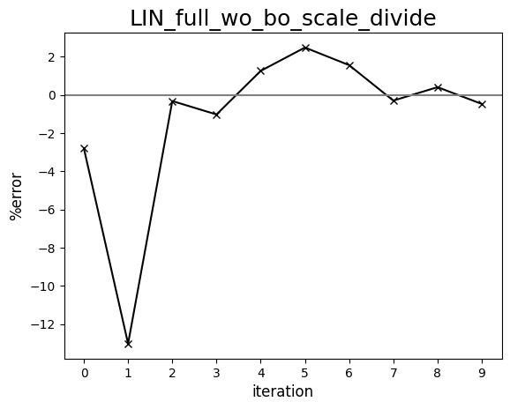

LIN scaling: multiplication

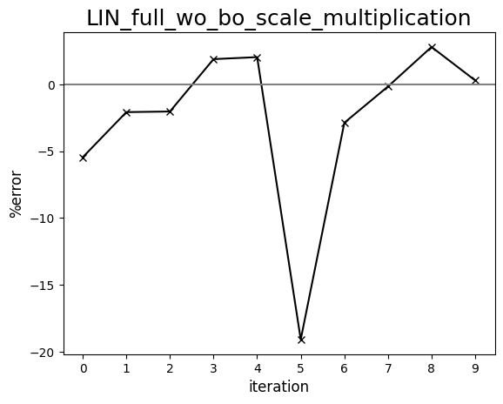

LIN scaling: without

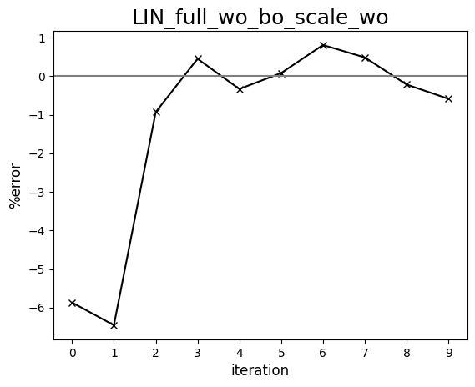

GPR scaling: division

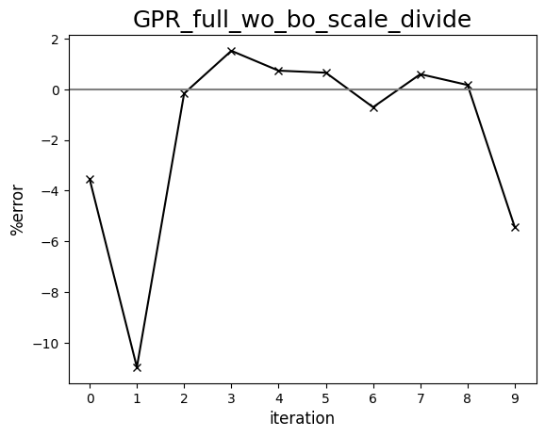

GPR scaling: multiplication

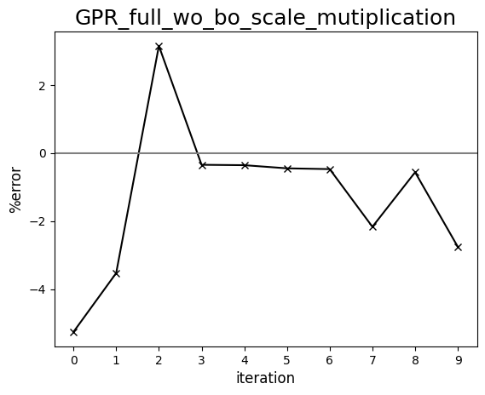

GPR scaling: without

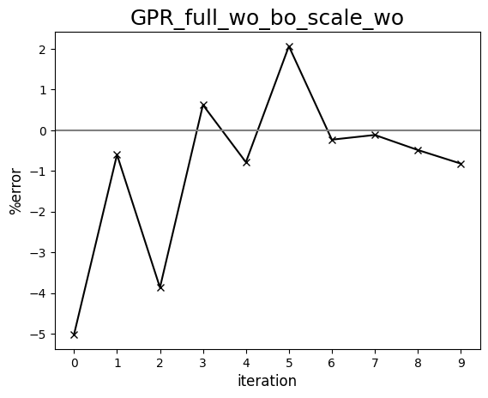

Diagram comparing human-driven and ML test trials (398 cP, set:full)

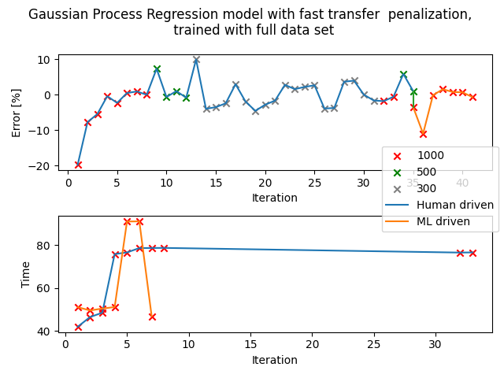

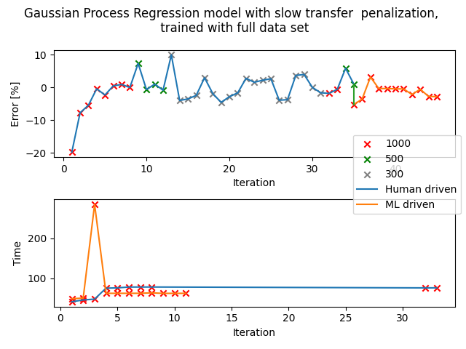

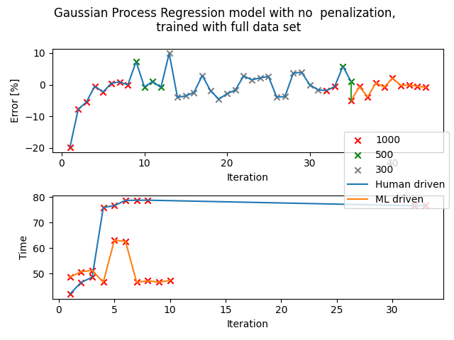

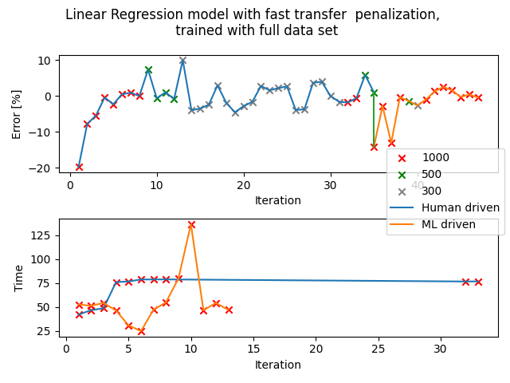

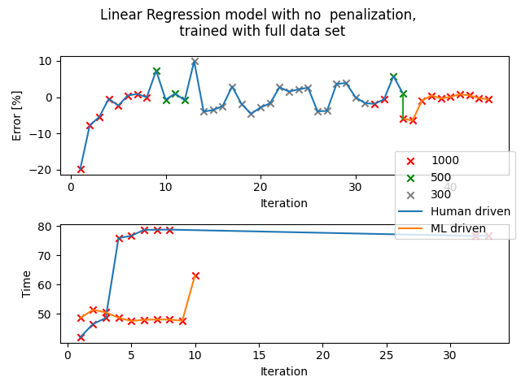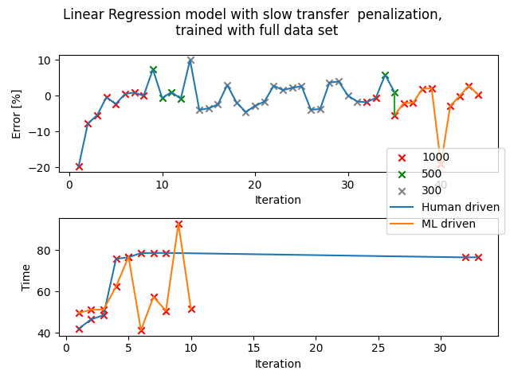

## Set: Full (unorderedT)

Observation of trends

Observation 1: GPR - scaling: multiply

Some repetitions in the sets of parameters generated but it does show a decent amount of variation (set: 1 trials often have more repetition, GPR especially - sometimes all 10 sets of parameters are the same). However, the sets of parameters generated do not seem to align with the penalization used. When it is changed to multiply, it should penalise slower transfer times but this iteration has more long time trials as compared to GPR - none, which does not have the penalization. The percentage error is not so bad,

Observation 2: GPR - scaling: none

In general, fast and relatively accurate trials, around 7 out of 10 trials are within tolerance of 1000uL. The time taken for transfer is similar to the average time taken for human driven section trials (standard calibration).

Observation 3: LIN - scaling: multiply

Slow transfer penalization seems to work on LIN. Overall short transfer time, not very accurate as seen in the data, only 5 to 6 out of 10 trials are within tolerance of 1000uL.

Observation 4: LIN - scaling: none

Accuracy is similar to LIN - multiply but much longer trials on average, a few trials even reached 200 seconds even though the standard calibration indicates around 80 seconds. However, at the last 5 trials, the model is able to discover sets of parameters that give very accurate transfer even though the 5 sets of parameters are very different, time ranges from 56s to 200s. (This shows that this iteration is prioritising low percentage error instead of shortening transfer times) Thus, one can suspect, in the long run this model can provide interesting parameters that are accurate.

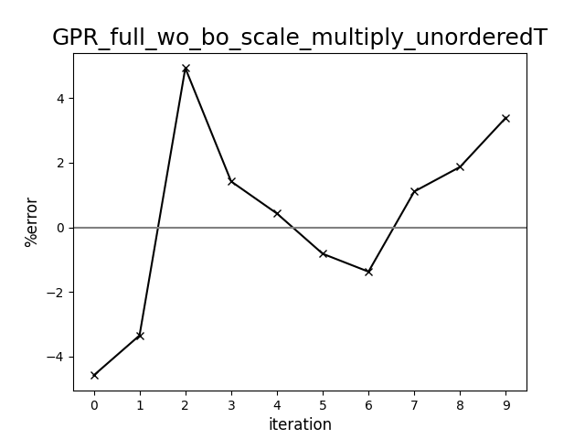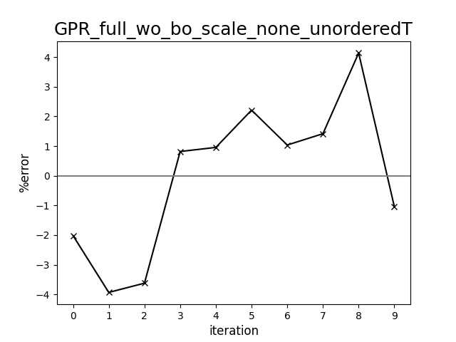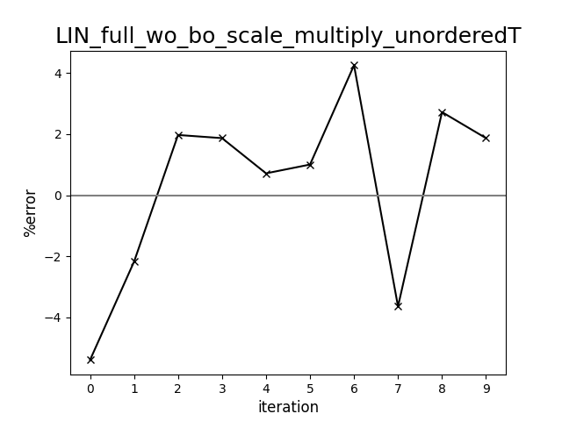

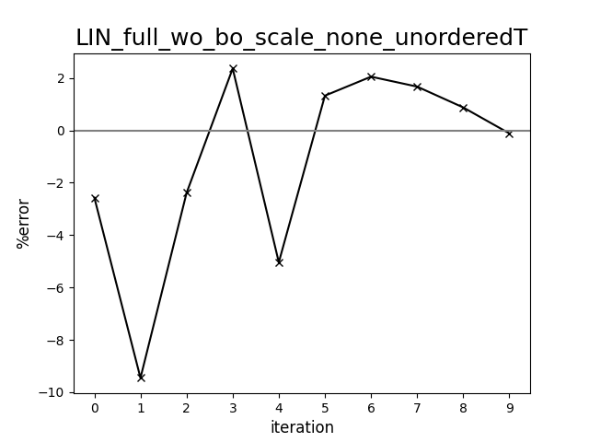

Diagram comparing human-driven and ML test trials (398 cP, set:full, unorderedT)

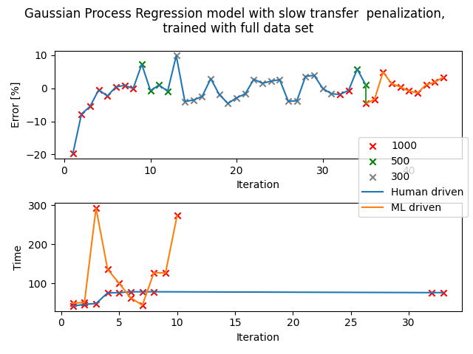

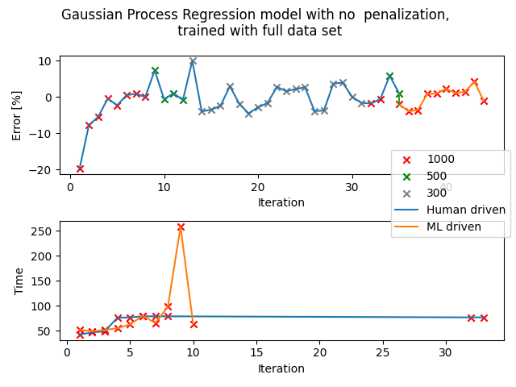

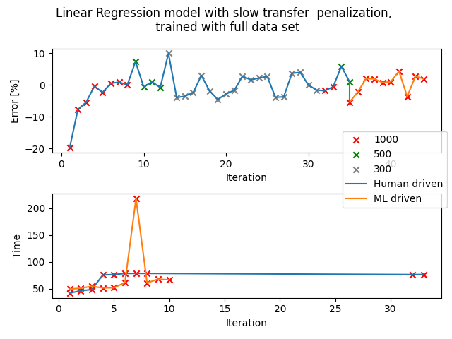

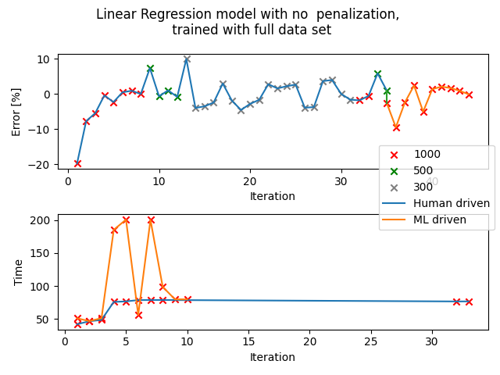

## Set: 1

Observation of trends

Observation 1: LIN - scaling: Without and LIN - scaling: Multiplication

Once an ‘optimal’ set of parameters are attained, it will double check once or twice to confirm, then continue to explore parameters. The ‘confirmation’ stage usually occurs in trial 5 or 6 of the 10 trials and it can continue to suggest parameters that deviate quite far from the ‘optimal’ set of parameters.

The error percentage fluctuates slightly between -2% to 2%, which is within tolerance of 1000uL. The sets of parameters are the most random out of the 3 observations (but does not have very big percentage error)

Observation 2: GPR - scaling: Division and LIN - scaling: Division

The sets of parameters generated are all prioritising faster transfer duration, neglecting the percentage error generated. On average, the percentage errors are all around -11 to -12% for both LIN and GPR models. The parameters do change but very slightly, all targeting at faster transfer rate.

Observation 3: GPR - scaling: Without and GPR - scaling: Multiplication

Both iterations show a lot of repetition in the parameters suggested. For scaling: without, the parameters are the same from trial 1 to trial 2 and also the same from trial 3 to trial 10. For scaling: without, the percentage error is an average of -3% while scaling: multiplication has percentage error of -2%. The sets of parameters suggested for GPR scaling: without and multiplication can be said to be almost identical.

Repetition is commonly observed for trials that use the GPR model, this pattern is consistent for both set: 1 and set: full.

It is worth noting that there are some sets of parameters that are repeated for many different iterations. It might help in determining the optimal set of data in the future. A few of such set of parameters are: (AR,DR,AD,DD)

* 52.3, 47.5, 3.1, 2.8
* 66.0, 66.0, 0.0, 6.0

GPR scaling: divide

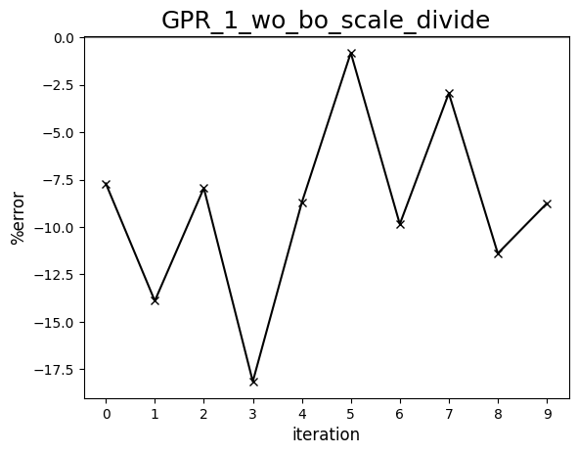

GPR scaling: multiplication

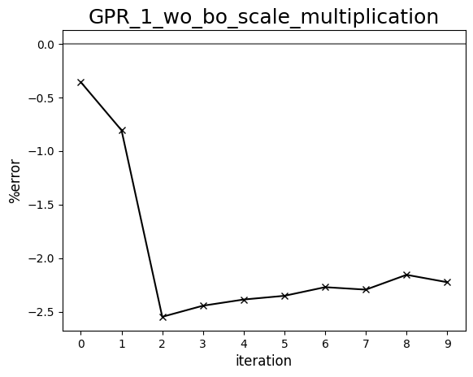

GPR scaling: without

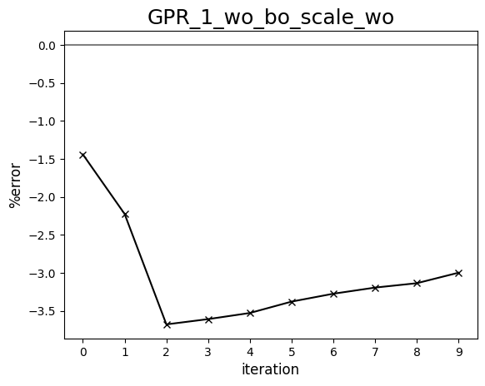

LIN scaling: divide

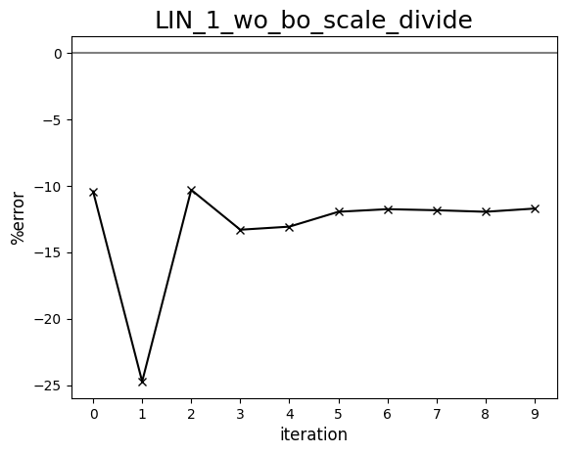

LIN scaling: multiplication

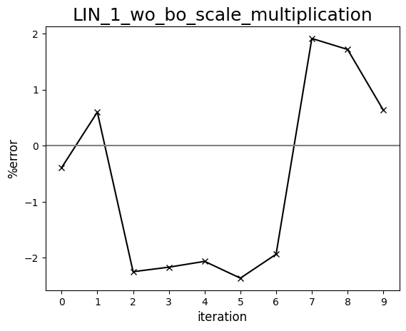

LIN scaling: without

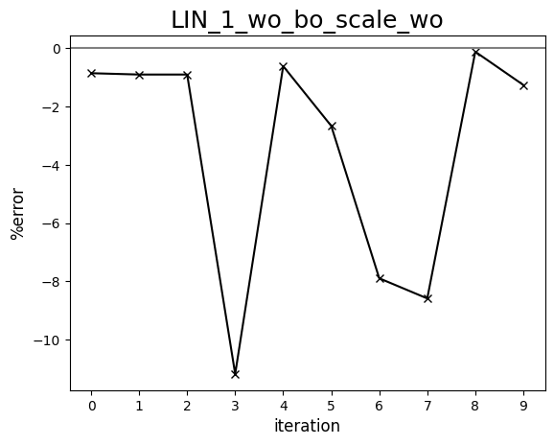

Diagram comparing human-driven and ML test trials (398 cP, set:1)

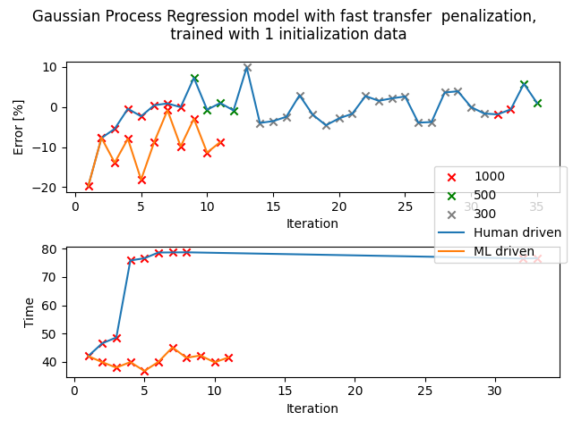

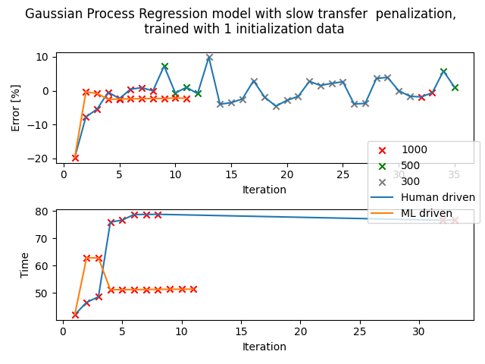

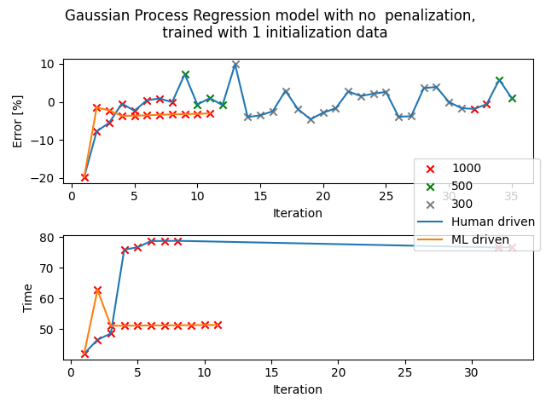

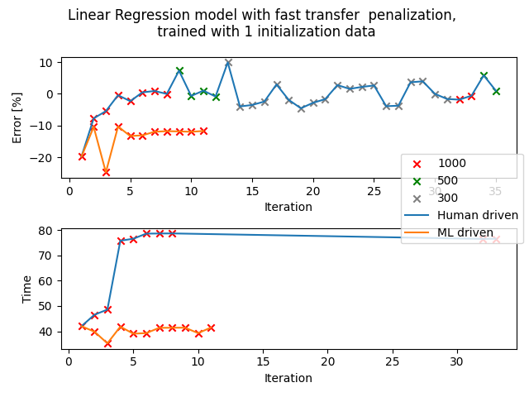

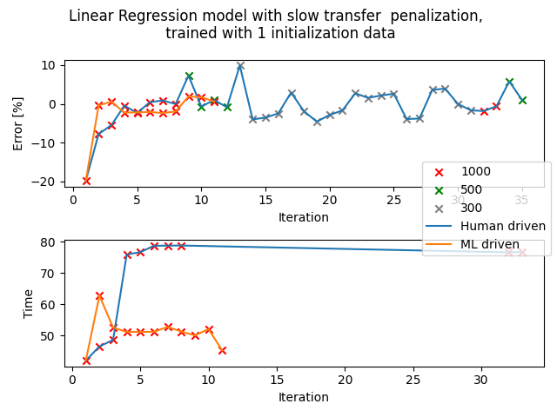

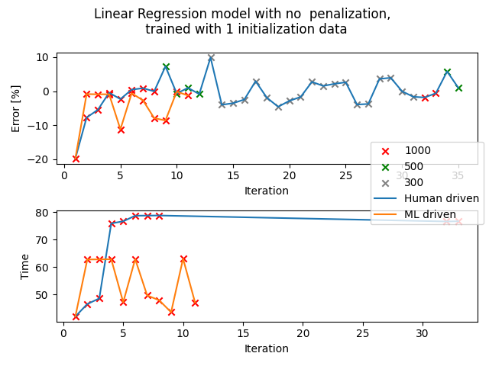

## Set: 1 (unorderedT)

Observation of trends

All iterations

All 4 iterations have sets of parameters that are exactly the same. Basically, the only set of parameters used is: (AR, DR, DA, DD)

34.6, 47.3, 4.3, 2.9

Despite the fact that all 40 trials are identical, the transfers are quite accurate. The percentage error falls between -1 to -2%. All trials took around 62 to 63 seconds, as compared to 80s derived from the standard calibration.

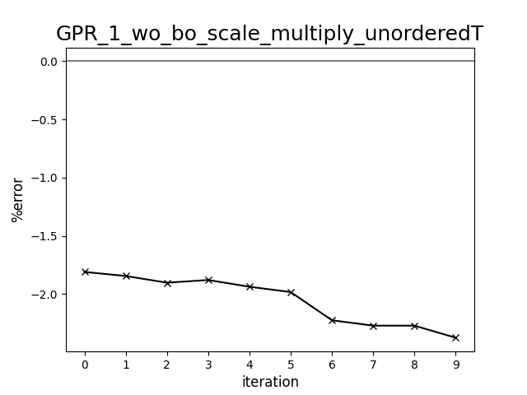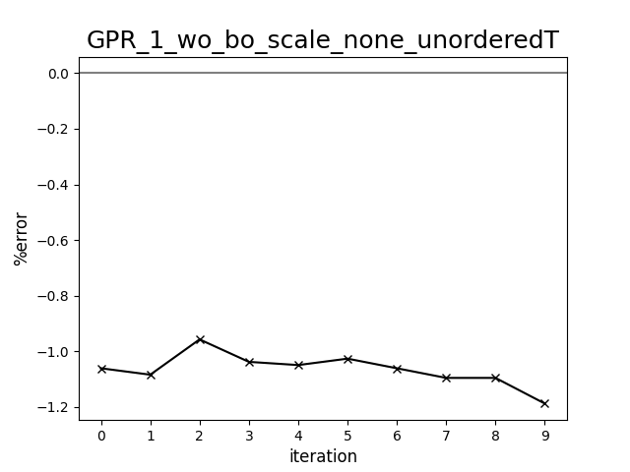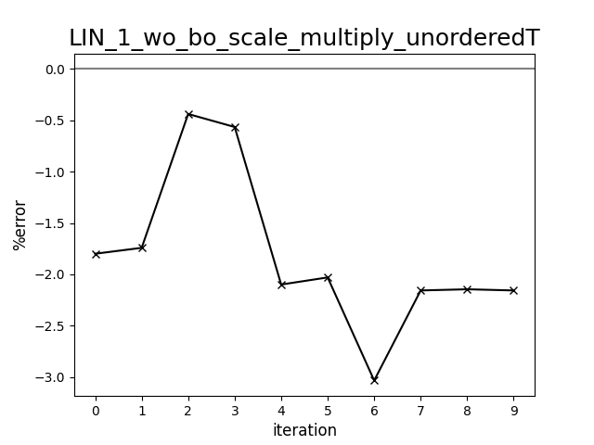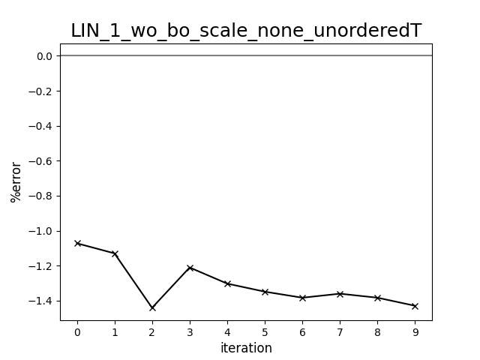

Diagram comparing human-driven and ML test trials (398 cP, set:1, unorderedT)

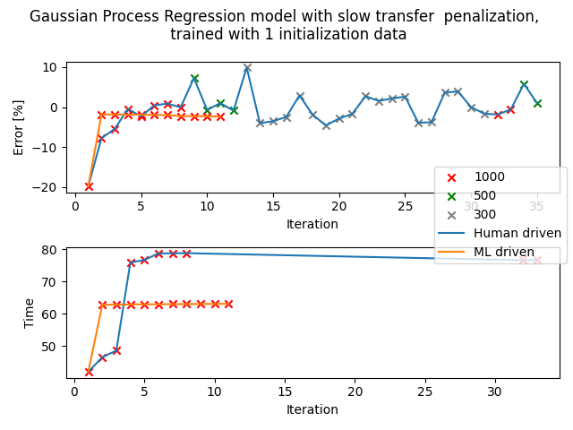

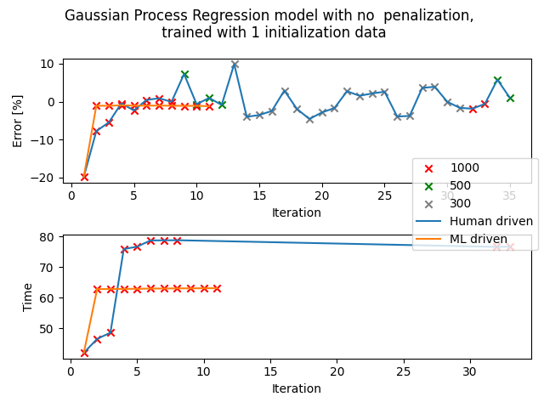

# Standard 1275 cP

Machine learning segment

## Set: Full

Observation of trends

Observation: GPR - scaling: Multiplication

The percentage error for this iteration is relatively consistent, ranging from -7 to -8%. A lot of repetitions in the sets of parameters generated are observed. The first 2 trials have the same sets of parameters and the rest of the trials share another set of parameters.

The most common set of parameters is: (AR, DR, DA, DD)

15.3, 7.0, 2.6, 4.5

Observation: GPR - scaling: Without

Repetitions of sets of parameters are also observed. The percentage error ranges from -3 to -7%, thus not as consistent as the trials with GPR - scaling: Multiplication.

The most common set of parameters is: (AR, DR, DA, DD)

11.1, 13.7, 4.1, 5.5

Observation: LIN - scaling: Multiplication

For this iteration, not as many repetitions are seen in the sets of parameters generated. Thus, the percentage errors are more distributed, ranging from -3 to -17%, with an average of -7%.

The most common set of parameters is: (AR, DR, DA, DD)

11.5, 7.3, 4.2, 3.6

Observation: LIN - scaling: Without

There are a lot of repetitions in the parameters generated, the parameters remained the same from the fourth trial onwards. The average is around -8%.

The most common set of parameters is: (AR, DR, DA, DD)

15.3, 7.0, 2.6, 4.5

GPR scaling: multiplication

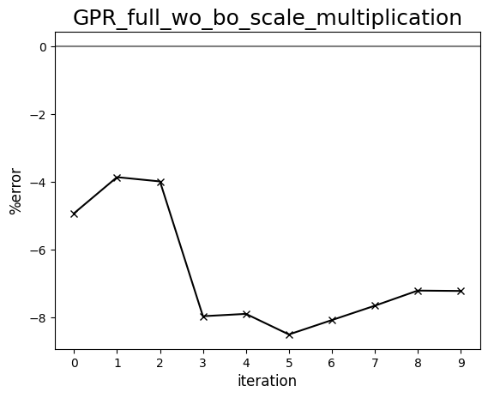

GPR scaling: without

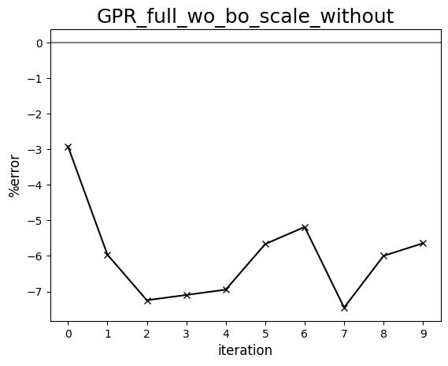

LIN scaling: multiplication

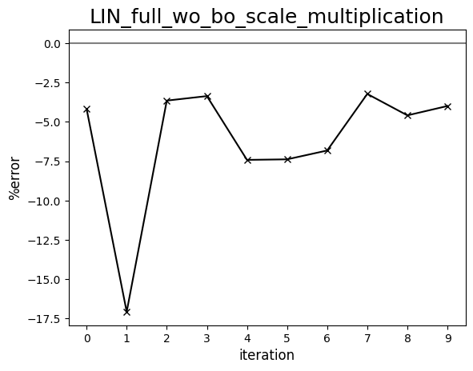

LIN scaling: without

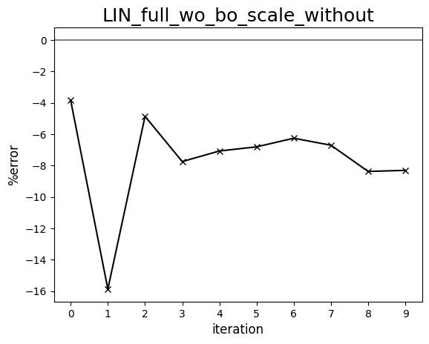

Diagram comparing human-driven and ML test trials (1275 cP, set:full)   
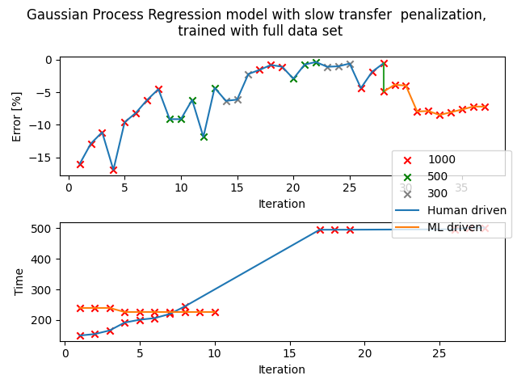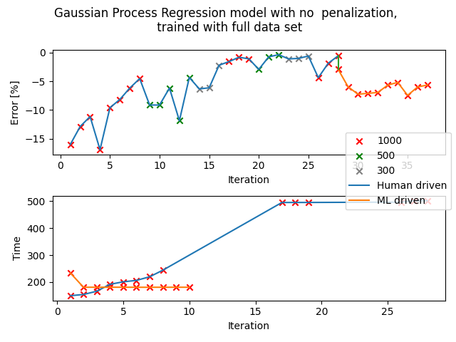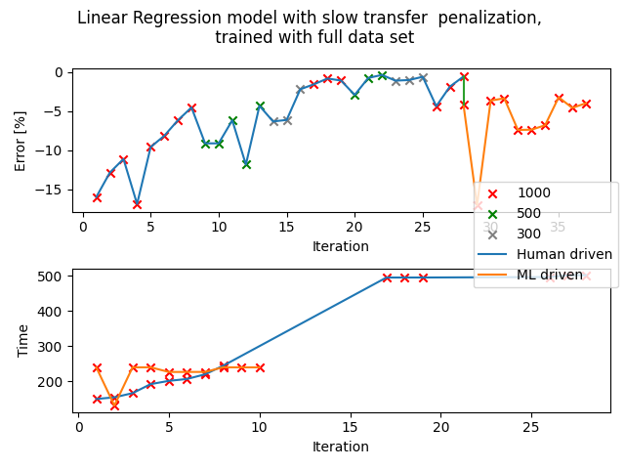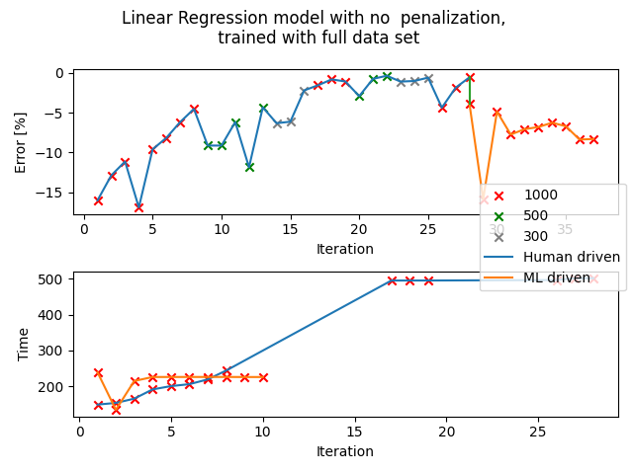

## Set: 1

Observation of trends

Observation for all iterations:

The parameters generated are more focused on quick transfer times than percentage error. Even though the transfer process will take around 160 seconds as derived from the standard calibration documents, most transfers only took between 90 to 140 seconds, with an average of 100 seconds.

Suggestion for improvement:

When I was doing the test trials, it was discovered that the first reading acquired will not be accurate. This is because the pipette tip has not been used and it is harder to aspirate and dispense the liquid as compared to one that is already “rinsed” with the standard. Since this is only discovered in the later part of this project, I did not manage to make amendments to the csv when I am still finding the standard calibrations. Thus, by using the first reading as the only point of reference, it might feed the system with the wrong information.

It is also worth noting that most trials have a percentage error of around -8% which is around the same error percentage that is caused by the “clean pipette error”.

One can try to use the second set of data collected instead. Although I’m not sure if it will work because even the trials with the full set of data as the reference points did not give very good parameters, but maybe the first data is prioritised (?) by the algorithm.

GPR scaling: multiplication

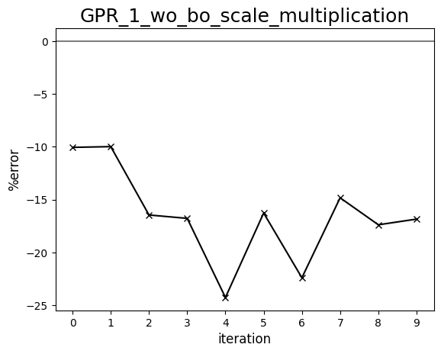

GPR scaling: without

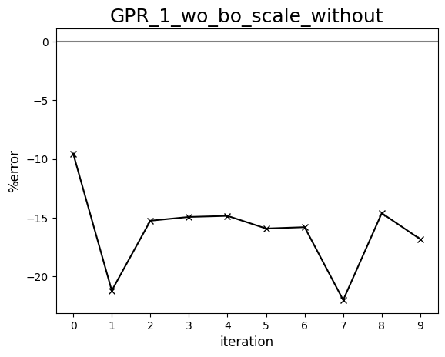

LIN scaling: multiplication

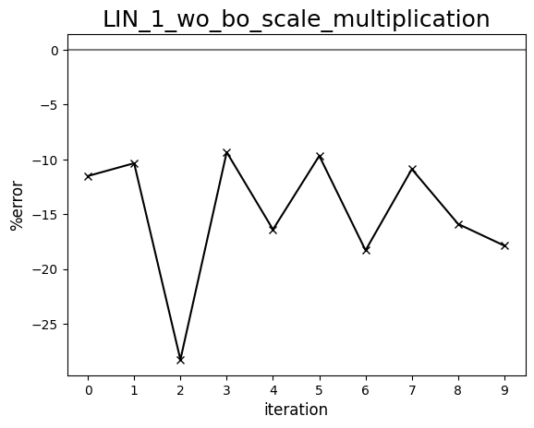

LIN scaling: without

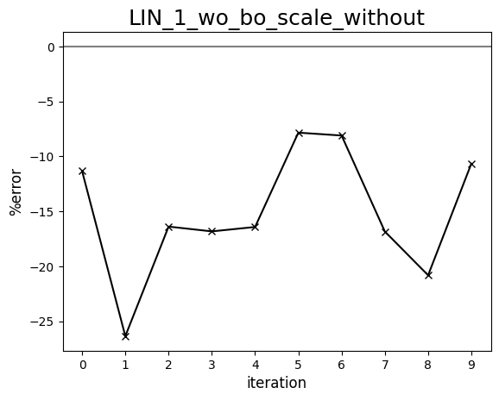

Diagram comparing human-driven and ML test trials (1275 cP, set:1)

